Security

- Instruct AI bot traffic with robots.txt - ON
- Block AI Bots Scope - Block on all pages.

Free bot fight mode was not enough. It blocked our requests to /ImageEventNotification and there was no easy way to bypass it. Rules doesn’t work on free bot fight. So we switched to Super bot fight.
Alternative - some kind of authenticating/signing requests to /ImageEventNotification, but it was harder to do.

Super Bot fight mode configuration:
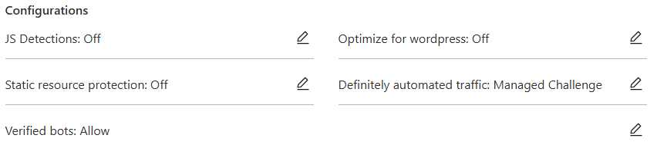

Security Rules

- Skip ImageEventNotification
  - Hostname equals modelsociety.com
  - AND
  - URI path starts with /ImageEventNotification/
  - (http.host eq "modelsociety.com" and starts_with(http.request.uri.path, "/ImageEventNotification/"))
  - Action - Skip
  - WAF components to skip:
    - All remaining custom rules
    - All rate limiting rules
    - All managed rules
    - All Super Bot Fight Mode rules
- Skip DonationWebHooks
  - Hostname equals modelsociety.com
  - AND
  - URI path starts with /DonationWebHooks/
  - (http.host eq "modelsociety.com" and starts_with(http.request.uri.path, "/DonationWebHooks/"))
  - Action - Skip
  - WAF components to skip:
    - All remaining custom rules
    - All rate limiting rules
    - All managed rules
    - All Super Bot Fight Mode rules

